wPets

You need to add 20 things to this document. (Make sure to number them just as I did in the example.) It may be helpful to copy and paste this list and then fill it in as you go along. All image names must start with your location, e.g yellowstone_sunset.jpg unless you are using a link from the internet.

1. Pet Name
2. Primary Image of Pet
3. Name of file with pet picture (make sure to add the picture to the proper Google Drive!)
4. Visual description of the animal.
5. Paragraph One about the pet
6. Paragraph Two about the pet.  
   1. For the next four pictures you can just put the names of the files, you don't have to include the files in this drive, but you do need to add them to the proper Google Drive.
7. **Photo Gallery – (Just write Photo Gallery)**
8. file name
9. Visual description of the image/movie
10. file name
11. Visual description of the image/movie
12. file name
13. Visual description of the image/movie
14. file name
15. Visual description of the image/movie
16. **Likes – (Just write Likes)**
17. Example 1
18. Example 2
19. Example 3
20. Your Name

## Cheeto (Chicken)

1. 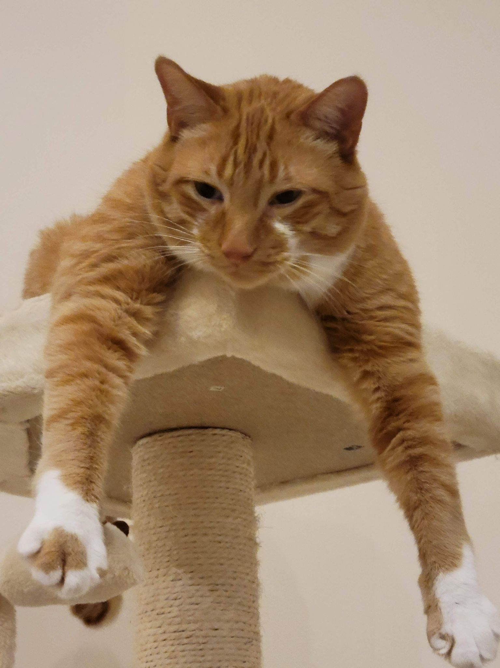
2. cheeto_cattree.jpg
3. Orange cat hanging paws off a cat tower
4. Cheeto is a cat who likes to eat a lot and play a lot. He has an obsession with his grandpa (human) and tries to get outside every single day. If he isn’t causing problems, he is usually hiding in a seven foot tall cat tree and sleeping.
5. Another name for Cheeto is Chicken, because sometimes he sits very scrunched up and ends up looking like a rotisserie chicken. He was nicknamed this by one of his friends, and now he understands it as his own name. He is about six years old and still acts like a younger cat, despite being middle-aged.

For the next four pictures you can just put the names of the files, you don't have to include the files in this drive, but you do need to add them to the proper Google Drive.

1. **Photo Gallery – (Just write Photo Gallery)**
2. cheeto_carpet.jpg
   1. Cheeto laying sideways on the carpet
3. cheeto_moon.jpg
   1. Cheeto lying in the sun in a half moon crescent shape
4. cheeto_boxes.jpg
   1. Cheeto lying on boxes with one leg hanging off.
5. cheeto_attack.jpg
   1. Cheeto attacking a hand trying to pet him.
6. **Likes – (Just write Likes)**
7. Treats
8. Exploring
9. My Dad
10. Divya Shankar

## Milktea

1. 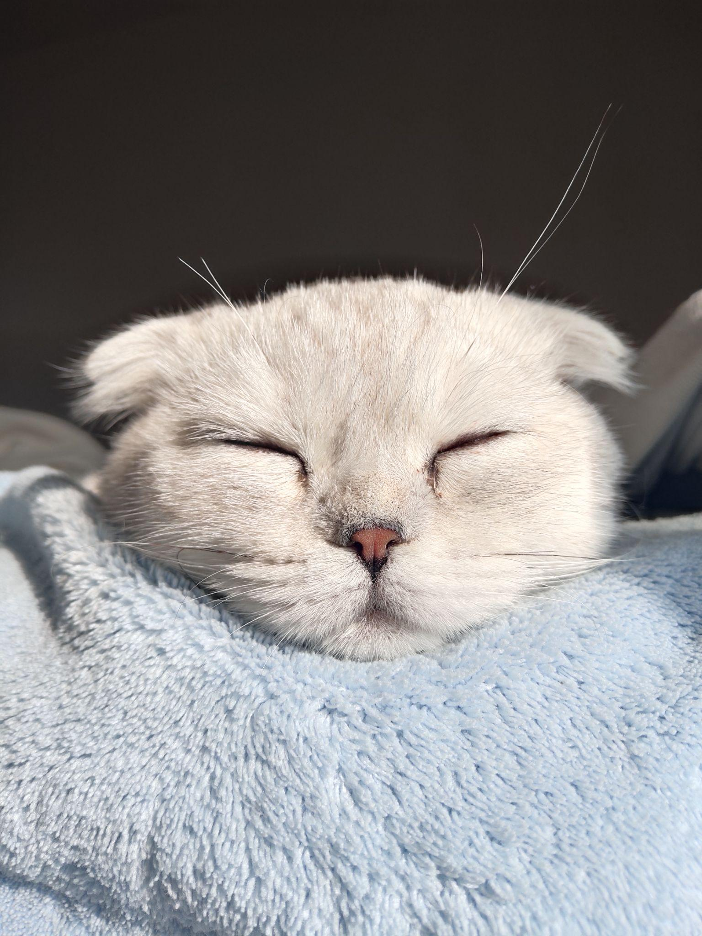
2. Filename: Main.jpg
3. Visual description: Milktea taking nap
4. Paragraph 1: Milktea is a Scottish fold with a personality of a princess. She loves her veggies and refuses to eat anything dropped on the ground. She makes it clear when she has a demand of any sort by complaining in a loud, distinguished manner. If what she says could be translated, it probably would be, “This is atrocious, the water container has been empty for the 3rd time this week. I want to see the manager.”
5. Paragraph 2: Despite her cuteness and royalty, she actually suffers from a genetic disorder intentionally brought upon by humans. I highly advise against keeping a Scottish fold because they are in constant pain when they reach around 2 years old. Cartilage accumulates around her paw joints and tail joints and it becomes painful for them to even walk. She is living evidence of human’s cruelty of breeding animals to look pretty while sacrificing the animals’ health.
6. **Photo gallery**
7. File name: Milktea_comfy.jpg
8. Visual description: Milktea enjoying a good massage
9. File name: Milktea_laptop.jpg
10. Visual description: Baby Milktea On Laptop
11. Filename: Milktea_mirror.jpeg
12. Visual description: Milktea sighing at mirror
13. File name: Milktea_catbox.jpg
14. Visual description: Milktea Catbox position

**16. Likes**

17. She loves individual corn kernels served on human hands

18. She enjoys sitting royally on suitcases to claim ownership of her humans

19. She prefers to be alone and sit on soft surfaces in her free time

20. Olive Ren

## Mochi

1. 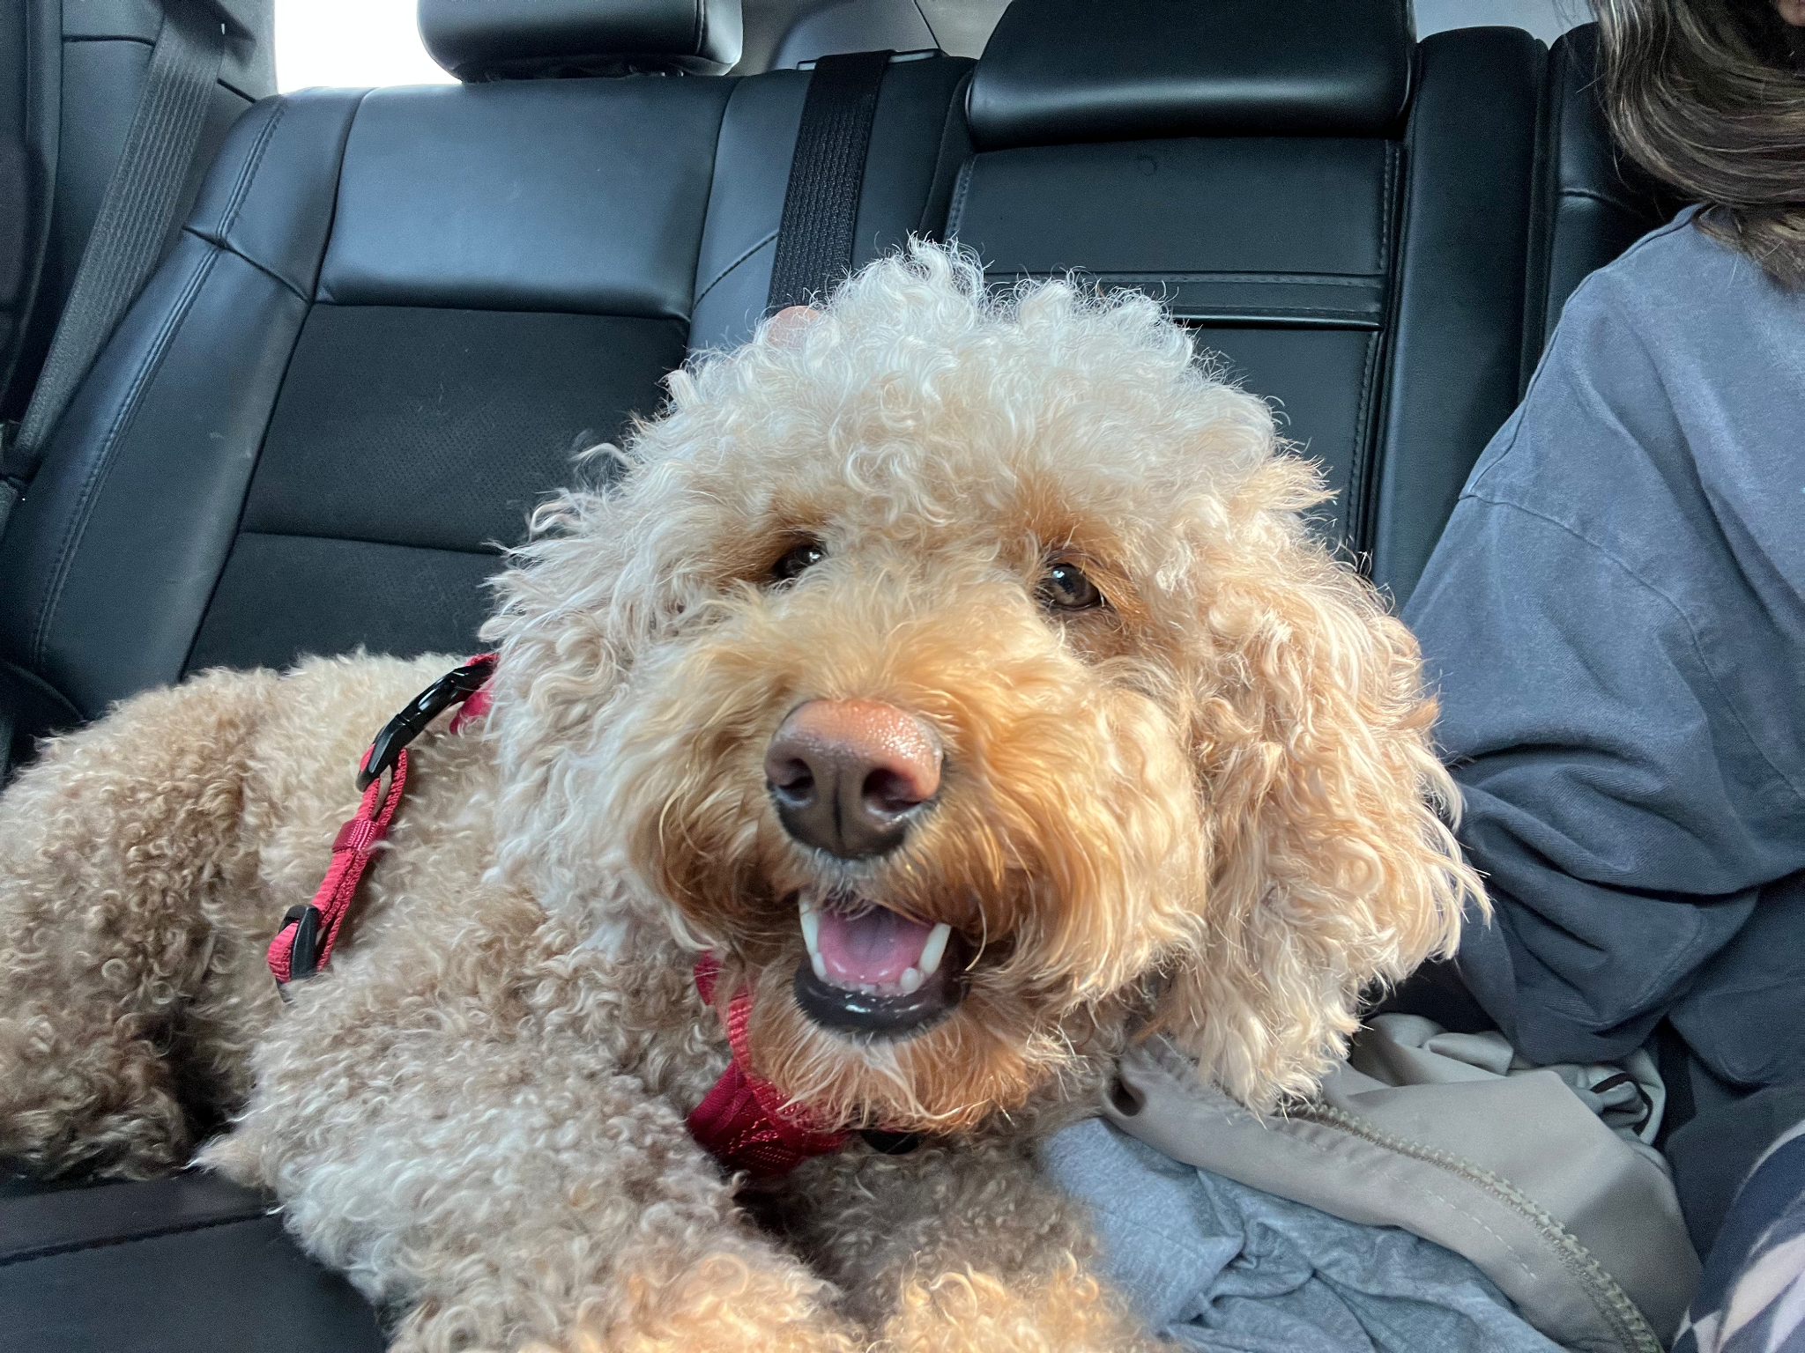
2. Mochi.jpg
3. Brown smiley dog
4. Mochi is my sister's dog, and we got her a little over two years ago. She is a true quarantine dog and therefore is scared of everyone— especially men. She hates my dad the most, and ironically loves my mom the most.
5. Currently Mochi is living in Arkansas, as my sister has gone to med school there. She enjoys the long winding pathways and nice greenery, which are very different from Baltimore which is where she used to live!
6. **Photo Gallery**
7. moch2.heic
8. Dog laying on couch with paws up
9. moch3.heic
10. Mochi sleeping with window behind
11. Moch4.heic
12. Mochi with hind legs stretched out funny
13. moch5.heic
14. Mochi looking scruffy
15. **Likes**
16. Peanut Butter
17. Laying in the sun
18. Playing fetch but not returning the ball
19. Sarasee Kiran

## Jax

1. 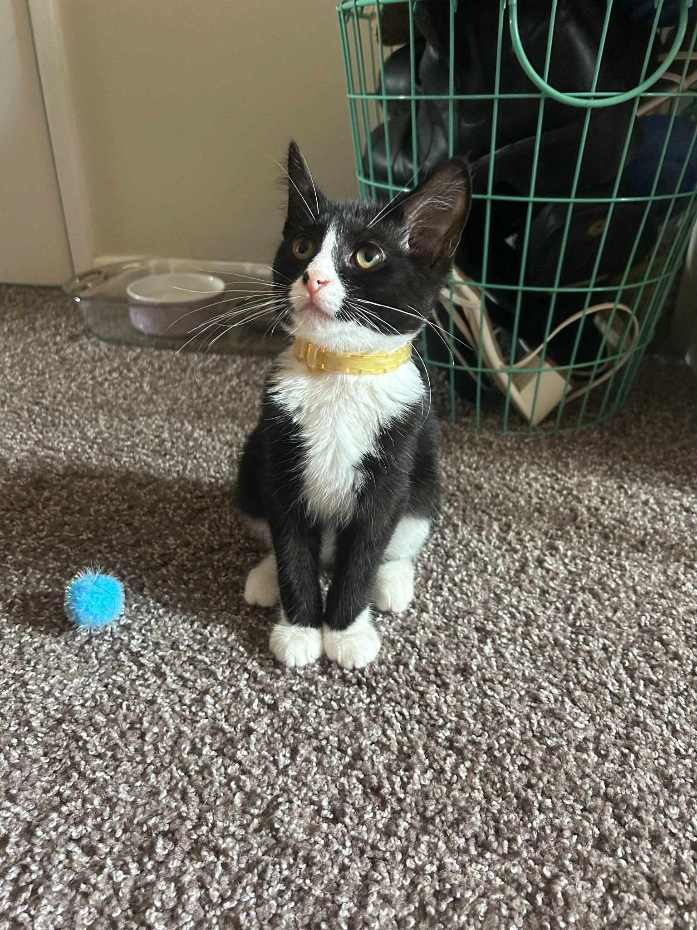Jax.jpg
2. A black and white kitten sitting down and wearing a yellow collar.
3. Jax is a kitten, about five months old that I found this summer at a gas station while traveling to Marquette, Michigan. He was scared and malnourished, crying in the parking lot. I took him with me and after some healthy meals and a trip to the vet he is doing great!
4. My roommates and I just recently moved and Jax has been having a hard time getting used to the large house since we were previously living in a small apartment. Jax is incredibly playful and loves to run around, but when he is sleepy he is happy to be held.
5. **Photo gallery**
6. JaxandMax.jpg
7. Black and white kitten standing on the driver’s arm while on a road trip.
8. JaxHarlowLake.jpg
9. Black and white kitten on a leash standing on a rock above a lake.
10. JaxSleeping.jpg
11. Black and white kitten sleeping on a windowsill.
12. JaxDashboard.jpg
13. Black and white kitten lying on the dashboard of a car while crossing the Mackinac Bridge.
14. **Likes**
15. Toys
16. Going outside
17. Attention
18. Grace Jermstad

## Ginger

1. 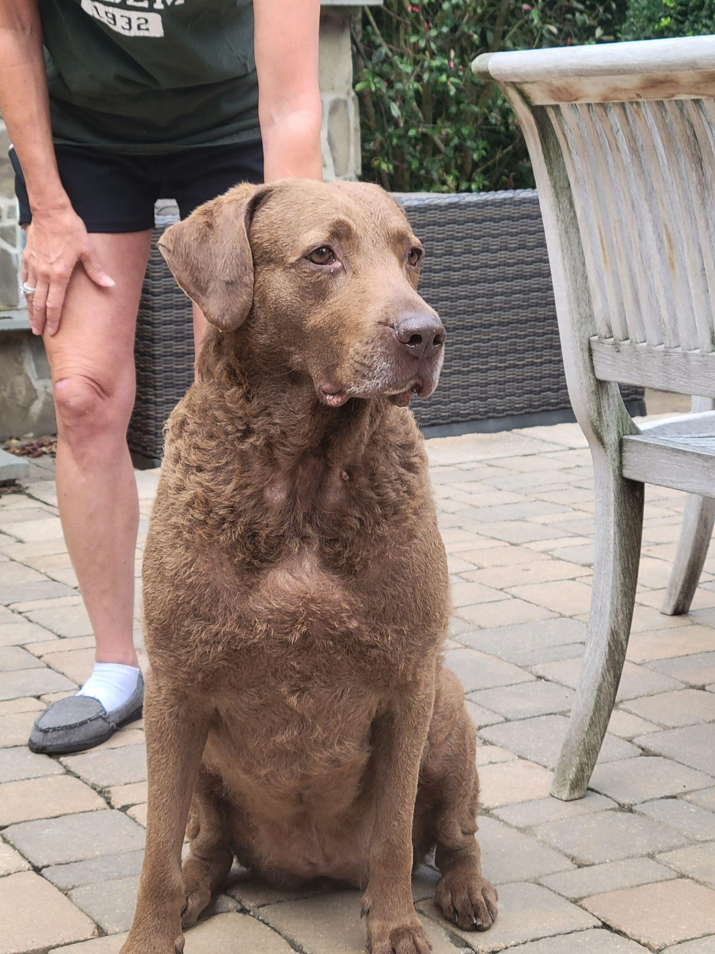
2. Ginger.jpg
3. Brown Chesapeake Bay Retriever sitting
4. Ginger is a 6 year old Chesapeake Bay Retriever. Her favorite activities are swimming in our pool and running around our yard. Occasionally she likes to chase after squirrels and groundhogs that pop up around our yard. She also likes to hog all the dog toys in the house so nobody else can have them. She enjoys antagonizing her younger brother Hank, and you can usually see them rough housing around the house.
5. When Ginger isn’t playing she enjoys sitting in her bed unbothered. She will go onto her bed, and then will turn on her selective hearing. That is when you know that she will side-eye you for anything you are doing.
6. **Photo Gallery – (Just write Photo Gallery)**
7. Ginger_Paw.jpg
8. Brown Chesapeake Bay Retriever pawing owner
9. Ginger_Puppy.jpg
10. Younger version of brown chesapeake bay retriever
11. Ginger_ToungeOut.jpg
12. 2 year old brown chesapeake bay retriever with tongue out
13. Ginger_gazing.jpg
14. Brown Chesapeake Bay Retriever laying down on white bed
15. **Likes – (Just write Likes)**
16. Pools
17. Toys
18. Her Brother Hank
19. Joseph Marino

## Leo

1. 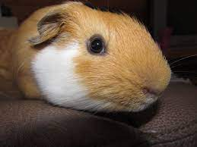
2. Leo_primary_photo.jpg
3. Guinea pig doing his best to smile for the camera
4. Guinea pigs are a naturally energetic animal, who spend up to 20 hours a day awake. Despite being awake for long periods of time, they naturally hide in their habitats, and can be difficult to see in their inclosures. Guinea pigs naturally are social creatures that enjoy socializing with other guinea pigs, in the wild they form packs of five to ten.
5. Leo is a half-lazy, half-lively guinea pig that either likes to run around on the floor, doing tiny hops, or likes to lay down in the cage for hours at a time nibbling at hay. His favorite hobby is eating, and he can tell whenever someone is about to give good to him by waiting at the end of the cardboard box patio he has attached to his cage.
6. **Photo gallery**
7. Leo_greens.jpg
8. Leo enjoying leafy greens.
9. Leo_run.jpg
10. Leo running across his cage as fast as he can.
11. Leo_smile.jpg
12. Leo smiling for the camera.
13. Leo_escape.jpg
14. Leo socializing with other guinea pigs as they plan their escape.
15. **Likes**
16. Lettuce
17. Tiny Hops
18. Nap Time
19. Justin Fischer & Alexei Chen
20. Chief
21. 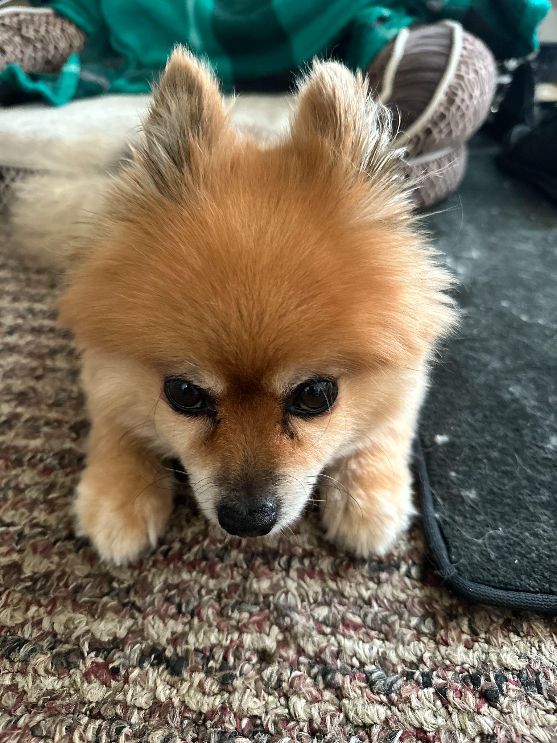
22. chief.jpeg
23. Pomeranian looking at camera with head bowed
24. Chief is a 9 year old pomeranian who loves to sleep as much as he can. He naps anywhere, ranging from someone's bed to the grass outside. He enjoys walking outside, but keep watch of him, otherwise he will try to consume geese poop.
25. He does not like any toys anymore as when he was younger, he watched a bigger toy shred his favorite one to pieces. He used to know how to roll over, but now replaced that memory with a spin as it is much easier.
26. **Photo Gallery**
27. chief_sleeping.jpg
28. Caramel pomeranian sleeping on his bed
29. chief_eating.jpg
30. Caramel pomeranian reaching for a slice of chicken
31. Chief_exposed.jpg
32. Caramel pomeranian resting with stomach exposed
33. Chief_bread.jpg
34. Caramel pomeranian with head poking through piece of bread
35. **Likes**
36. Sleeping
37. Deli Chicken
38. Pets behind the ear
39. NaveenJohn Premkumar